a) left panel showing the head at the well and right panel showing the head at the midopint of the domain, both as functions of time over the entire simulation.

Figure : Head Change over time at the well and at the midpoint of the midpoint of the domain across the whole 10 year time period.

Figure : Head Change at well and center of domain for 100 year period

b) The head along a transect between the constant head boundaries through the well at three times: the initial steady state; the final pump-on period; and the final pump-off period.

Figure : Head at three points along the domain.

Figure : Heads at segments denoted in figure 3 for the 100 year transient simulation

c) A contour map with flow vectors at three times: the initial steady state; the final pump-on period; and the final pump-off period.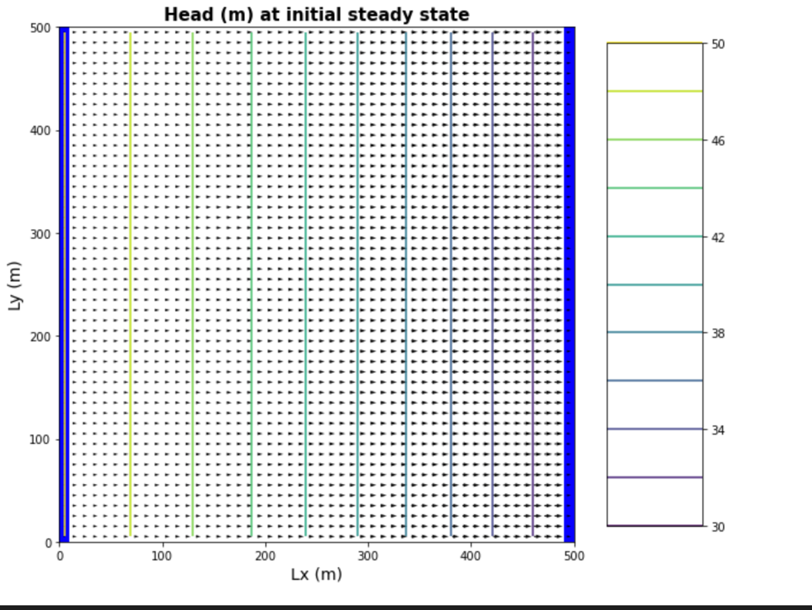

Figure : Contour Head Plot of the Initial Steady State Conditions for ten year period

Figure : Contour plot of last time pumping was on for 10 year period

Figure : Head contour for the last time step over the 100 year period

d) A contour map of the drawdown calculated for two periods: between the initial steady state and the final simulation time and between the final pump-on period and the final pump-off period.

Figure : Drawdown across the full 100 year period of transient simulations